Exercise 2. Transformation and Amplification of Plasmid DNA

Objectives
Plasmids are important vehicles for the introduction of recombinant genes from one organism to another. In this exercise, you will use E. coli. cells which have been made competent. These cells will be transformed with foreign plasmid DNA. Methods for verifying successful transformation will be encountered. You should also understand the genetic control systems involved that allow for simple plasmid amplification and control plasmid replication.

PreLab Questions 2

Please limit your answers to a few sentences IN YOUR LAB NOTEBOOK

- E.coli BL21 cells double about every 30 minutes in LB media at 37oC. If the OD of an E.coli culture grown overnight is 1.0, how much should the culture be diluted in order to get an OD of 0.4 one and a half hours after dilution?

- What is meant by cell competency? What are the two essential characteristics of a plasmid?

- If competency can only be achieved in a fraction of cells, how do you distinguish transformed cells from those not transformed after inoculation and incubation on your LB/Kan or LB/Cm agar plate?

- What chemicals are used in making cells ready for heat shock transformation? Electroporation?

- What is the mechanism of action of kanamycin? Chloramphenicol?

Background
Rapidly growing cells can be made competent, or permeable to DNA by incubating with the DNA in cold TRIS buffer containing CaCl₂. The DNA is taken up from the buffer, facilitated by a brief heat shock. This technique has been applied since 1973 (Cohen, Chang, and Hsu) and is a common experimental technique for transferring a plasmid from one bacterial strain to another. A plasmid is a small, circular DNA molecule that replicates independently of the host cell chromosome. Permeable cells are labeled competent, and can maintain this competency for only a short while, seldom longer than 1-2 days. With this procedure, usually only ~10⁶ transformed cells are obtained per μgram of intact plasmid pET30 DNA. This works out to essentially one DNA molecule in approximately 10,000 transformed.
Techniques for producing competent cells with salts like CaCl₂ have improved greatly over the years. Commercially available cells (e.g. from Stratagene) can yield > 1.0 x 10⁹ transformants /μg pET30 plasmid DNA. Additionally, competency can be maintained for many months, even years, when cells are stored at temperatures near –70 °C. Another technique to transform cells developed more recently, which is easier and more efficient, is electroporation. In electroporation, cells that have been carefully washed with water and PEG are placed in solution with the plasmid and submitted to a large electric potential. The electricity opens pores in the cell membrane through which plasmids can diffuse. The pET30 plasmid contains a gene that confers resistance to kanamycin for any cell that has been transformed. The pHT43 plasmid contains a gene that confers resistance to chloramphenicol. Transformed cells can be selected by adding kanamycin or chloramphenicol to the growth medium. Cells that have not been transformed will be sensitive to the antibiotic and will not form stable colonies.

In order to isolate adequate amounts of plasmid DNA from small volumes of transformed cell lines, it is desirable to use plasmids which exist at a high copy number within the cells. In this experiment the pET30 and pHT43 plasmids will be used since they has an inherently high copy number. This will make the isolation of plasmid DNA in easier subsequent experiments. Note that the pET30 plasmid has an origin of replication for E.coli, and thus can be copied in this host, but does not contain an origin for B. subtilis, so will not be amplified. The pHT43 has origins of replications for both E.coli and B.subtilis.

Plasmid Amplification
Plasmids are generally maintained in stable copy numbers within cells from generation to generation. Generally, plasmid DNA replication can be controlled independently of chromosomal DNA replication. The synthesis of host chromosomal DNA requires unstable proteins (i.e., DnaA protein), but relaxed plasmid replication utilizes only stable host enzymes. Therefore, in the absence of these unstable proteins, plasmid DNA will be replicated and chromosomal DNA replication will cease. Chloramphenicol is an antibiotic that can inhibit the synthesis of proteins, sharply reducing the concentration of unstable proteins that must be continually synthesized to remain in high concentrations. Plasmid copy numbers can reach 1000 or more in the presence of chloramphenicol.

For many plasmids, copy numbers are regulated by an inhibitor encoded by a gene on the plasmid itself. This inhibitor is a negative regulator of the initiation of replication, i.e. it binds to the specific site on the circular plasmid where replication originates and prevents the replication enzyme from binding. Some plasmids are also under stringent control and require certain “activating” proteins for replication. As a result, these are usually present as only one or a few copies per cell.

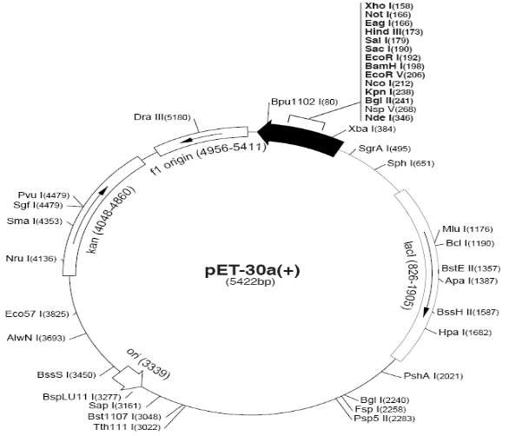
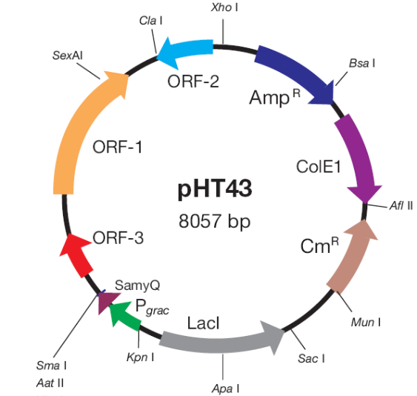

Procedure
NOTE: Sterile technique is required for all protocols; this is especially important when you are growing cultures in antibiotic-free medium. Use a flame, cover things, and if a specimen is thought to be contaminated, trust your judgment and start over. All “sterile” items provided to you were packaged sterile or were autoclaved at 121o C. Remember to read procedures carefully and do any necessary calculations before coming to lab, so time won’t be wasted while in lab. Also, label everything clearly, as large numbers of tubes and plates can easily be confused.

Transformation of E.coli (procedure taken from Invitrogen)

- Remove one 1.5 ml tubes of competent cells (with 200 μl cells) from the dry ice cooler. Label this tube “pET30.” Take an empty tube and label it “Control.” Place both on ice for 5-10 minutes.

- Carefully aliquot 100 µl of competent cells from “pET30” into the chilled “Control” tube.

- Add 50 pg, (5 μ)l, of pET30 DNA (0.01 μg/ml) to the “pET30” cells. Move the pipette through the cells while dispensing (DO NOT PIPETTE THE SOLUTION UP AND DOWN). Gently tap tube to mix. Add 5 μl sterile water to the second “Control” tube.

- Incubate 30 minutes on ice.

- Heat shock the tubes for exactly 45 seconds in a 42 °C water bath; do not shake.

- Place the tubes on ice for 2 minutes.

- Add 0.5 ml sterile SOC media to the tubes and invert gently to mix. Incubate at 37 oC for 45-60 minutes to allow expression of antibiotic resistance coded by the newly-incorporated plasmids.

- The plasmid pET30 codes for kanamycin resistance. Using a Pipetman and sterile tips, pipette various aliquots of the pET30 culture (10, 100 μl) onto LB/Kan plates. We will be using pre-sterilized, disposable cell spreaders. Remove one spreader from the wrapping; be careful to NOT touch the triangular portion of the spreader. Place the flat portion of the spreader in the center of the plate and move in a circular motion to evenly spread the cell suspension. You will need to share cell spreader packages with other groups. Use a fresh spreader for each plate. Spread a third LB/Kan plate with 100uL of the control competent cells. Remember to properly label your plates.

- Put the completed plates in the 37 °C incubator “right side” up (agar on bottom). This allows them to dry. After 15 minutes turn them over, so that the transformed cells can grow into colonies overnight. The plates will be taken out and placed in the refrigerator the next day, after colonies have formed. A plate can remain in the refrigerator for over a month and remain viable.

Transformation of B. subtilis (Stepheson M, Jarret P. (1991). Transformation of Bacillus subtilis. Biotech. Tech 5. pp 9-12)

- Prepation of B. subtilis for electroporation (already done)
  - Grow in GP293 in 100mL LB to OD₆₀₀ ~ 1.0
  - Harvest (8000g 10min)
  - Wash 3x cold deionized water
  - Resuspend in 30% PEG to 1% original volume (1mL)
  - Aliquot to 200ul, flash freeze
  - Store at -70C

- Pre-chill electroporation cuvette and SOC media

- Take out frozen GP293 vial and thaw on ice for 8min

- Add 5uL of pHT43 plasmid and swirl gently

- Transfer mixture to pre-chilled electroporation cuvette

- Wipe sides of cuvette with Kimwipe

- Place in electroporator [EPH will do this for you]

- Pulse briefly (1sec) [EPH will do this for you]

- Pulse settings: (resistance 400Ohm, capacitance 25uF, voltage 1.25kV (12.5kV/cm with 0.1cm path length) Time constant should be ~6msec

- After pulse, transfer cell mixture to 400uL SOC

- Shake at 37C for 60min for antibiotic resistance to develop

- The plasmid pHT43 codes for chloramphenicol resistance (at ~20ug/mL). Using a Pipetman and sterile tips, pipette various aliquots of the GP293 culture (10, 100 μl) onto LB/Cm plates. We will be using pre-sterilized, disposable cell spreaders. Remove one spreader from the wrapping; be careful to NOT touch the triangular portion of the spreader. Place the flat portion of the spreader in the center of the plate and move in a circular motion to evenly spread the cell suspension. You will need to share cell spreader packages with other groups. Use a fresh spreader for each plate. Spread a third LB/Cm plate with 100uL of the control competent cells. Remember to properly label your plates.

Guidelines for Analysis & Conclusions Section
(Remember, these are points you should consider and include in your analysis. This section, however, need not be limited to these specific guidelines.)

1. Compare the appearance of your plates which have different amounts of transformed cells. Which amount is the best? What do you expect these plates going to be used for later?

2. If there are any differences between your expectations and the actual results, give reasons for the discrepancies. Pay special attention to the control plate.

3. Discuss the importance of this technique with regards to biotechnology, knowing that it is possible to incorporate any gene of interest into these plasmids.

4. The copy number of a particular plasmid is determined by the concentration of a plasmid-encoded inhibitor of plasmid DNA synthesis. How would the concentration of this inhibitor be expected to affect the copy number? How would the concentration of the inhibitor depend on the number of plasmid copies (i.e., the number of copies of the inhibitor gene)? Why would protein synthesis inhibition lead to lower inhibitor concentration and hence higher copy numbers?

5. Recent controversy has arisen regarding the over-prescription of some antibiotics to paranoid patients. Based on what you’ve learned in this experiment, why is this often seen as a disaster waiting to happen?
Equipment and Reagents

BL21 competent cells
1 - 1.5 ml tubes with 200 μl competent cells
pET30a plasmid DNA: 0.01 μg/ml solution (supplied with competent cells from Invitrogen)
pHT43 plasmid DNA
Sterile water
SOC Medium, sterile
LB agar plates containing 50ug/mL Kanamycin, or 20ug/mL Chloramphenicol
Disposable cell spreaders
Ice bucket w/ice
42°C bath
Sterile pipet tips
Pipetman
SOC media:
• Add the following to 900ml of distilled H₂O
  - 20g Bacto Tryptone
  - 5g Bacto Yeast Extract
  - 2ml of 5M NaCl.
  - 2.5ml of 1M KCl.
  - 10ml of 1M MgCl₂
  - 10ml of 1M MgSO₄
  - 20ml of 1M glucose
• Adjust to 1L with distilled H₂O, sterile filter at 0.22um

References
Cohen, S. et al. (1973) Proc. Natl. Acad. Sci. (USA), 69, 2110.
Minch, M.J. (1989) Experiments in Biochemistry, Projects and Procedures, pp. 230-235, Prentice-Hall, Inc., Englewood Cliffs, New Jersey.
Rodriguez, R.L. and D.T. Denhardt, Eds. (1988) Vectors: a survey of molecular cloning vectors and their uses, pp. 5-6, 17-20, Butterworth Publishers, Boston.
Sambrook, Fritsch, and Maniatis. (1989) Molecular Cloning - A Laboratory Manual, 2nd ed., Cold Spring Harbor Laboratory Press

A good reference for many molecular biology techniques that is widely used in many laboratories is Molecular Cloning - A Laboratory Manual, 2nd ed. by Sambrook, Fritsch, and Maniatis. This book, aside from giving detailed laboratory techniques, has fairly comprehensive background information on plasmids, transformation, isolation, and much more, with the original journal references.

